AQ-1 Cybersecurity Architecture & Threat Assessment
  - Technical Artefact 3

1. Security Scope & Objectives

1.1 Purpose and security context
This artefact explains the cybersecurity design of our AQ-1 aquaculture monitoring prototype. The larger design covers three ponds, but our university setup uses an ESP32-C3 temperature sensor, simulated DO and pH publishers, MQTT, a Python gateway, Node-RED and SQLite. We focus on how the system handles incorrect, forged or missing sensor readings.

1.2 Security objectives
Our main goal is to stop untrusted readings from appearing as reliable sensor data. The gateway checks an HMAC signature and message sequence before accepting a reading. The system also looks at the last valid reading to detect outages and show a software SAFE/HOLD warning. HMAC protects message integrity but does not encrypt data or stop replay attacks on its own (Krawczyk, Bellare & Canetti 1997).
Objective | Security requirement | Prototype mechanism
Integrity | Detect altered sensor values and identifiers | HMAC-SHA256 verification at Python gateway
Source authenticity | Accept only messages bearing a valid shared-secret tag | Publisher signing and gateway comparison
Availability awareness | Identify interrupted or stale trusted readings | Last-valid-reading monitoring and outage indication
Safe response | Avoid relying on unavailable or rejected data | Software SAFE/HOLD state in demonstration
Operator visibility | Distinguish trusted values from suspicious or absent traffic | Monitoring output and Node-RED dashboard

1.3 Protected assets and boundaries
We need to protect sensor values and identities, HMAC keys, the gateway checks, trusted readings and dashboard status. The MQTT broker passes messages between devices, but a message arriving at the broker does not mean it is trusted. Our attacker node is separate from normal sensors, and no real farm machinery is controlled.

1.4 Assessment method
We used STRIDE to think about six kinds of threats: spoofing, tampering, repudiation, information disclosure, denial of service and elevation of privilege (Microsoft n.d.). We rated risks as low, medium or high for our demonstration and linked them to controls or remaining weaknesses. Detailed testing results are in Artefact 4.

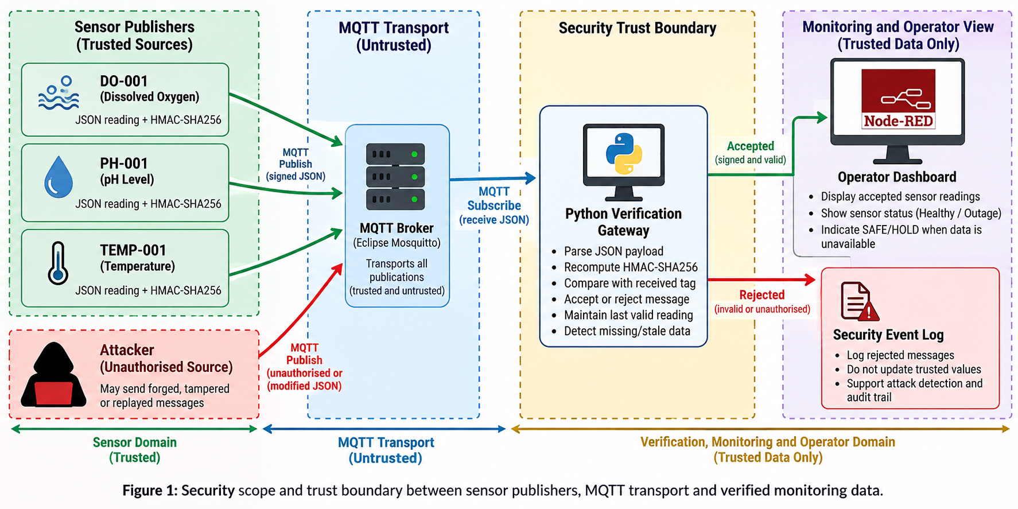
Figure 1: Trust zones separating sensor publishers, untrusted MQTT transport, gateway verification and monitoring.

2. Cybersecurity Architecture

2.1 Data flow and trust decisions
Sensors send JSON readings with identity, measurement details, sequence number and HMAC. The ESP32 temperature message also includes a status field. MQTT carries these messages through the public HiveMQ broker to our Python gateway. The gateway checks the signature and sequence before updating trusted readings shown in Node-RED and SQLite (OASIS 2019).

2.2 Security zones and interfaces
Zone / component | Trust assumption | Security boundary
Sensor publishers | Legitimate software sources hold signing material | Signed data enters MQTT transport
MQTT broker | Transports publications; payloads are not inherently trusted | Broker delivery to verification gateway
Verification gateway | Applies HMAC comparison and acceptance decision | Unverified messages separated from accepted state
Monitoring and Node-RED | Displays accepted readings and availability indications | Operator view must not trust raw attacker publications
Attacker VM / team computer | Authorised adversarial traffic source | Untrusted publications tested against gateway

The transferred GNS3 project defines separate Alpine Docker nodes for Attacker1, DO-001, PH-001 and AQ1-Gateway together with NAT1, Switch1 and AQ1-Monitor. The physical temperature publisher operates outside those Docker nodes. GNS3 is hosted via VMware, and the logical trust zones must not be mistaken for production-grade segmentation. Optional cross-location testing remains a planned scenario unless separately supported by recorded results.

2.3 HMAC-based message integrity
HMAC-SHA256 helps us detect whether a signed sensor message has been changed. If someone changes the value but keeps the old HMAC, the gateway should reject it. The temperature sensor signs eight fields including status; the simulated DO and pH sensors sign seven. Both sides must use the same field order and format (Krawczyk, Bellare & Canetti 1997).

2.4 Availability monitoring and SAFE/HOLD
We track the time of the last accepted reading, not simply the last message received. Otherwise, repeated fake messages could make an offline sensor look active. If valid readings stop arriving, the monitoring system can show an outage and a SAFE/HOLD warning. This is a software indication only.

2.5 Security control boundaries
The exported gateway performs HMAC verification and sequence-based replay checking, retaining the latest accepted sequence in replay_state.json. GNS3 DO/PH messages also receive timestamp freshness checks. The ESP32 firmware uses an uptime-based timestamp, so Unix-time freshness checking is not applied to its messages; sequence checks still apply. Broker authentication, topic ACLs, TLS and strong device-specific key management are not demonstrated by the public HiveMQ setup (Eclipse Foundation n.d.).

3. Threat Modelling & Risk Assessment

3.1 Threat actors and entry points
For our demo, the attacker is an authorised GNS3 node or team computer that sends manipulated MQTT traffic. In a real deployment, possible threats would also include compromised sensors, unsafe broker settings or excessive user access. We mainly test what happens when untrusted data enters the MQTT path.

3.2 STRIDE threat analysis
STRIDE category | AQ-1 threat example | Control / exposure
Spoofing | Impersonated simulated sensor identity | Invalid tags rejected; shared-key identity remains limited
Tampering | Changed measurement with unchanged HMAC | Gateway detects HMAC mismatch
Repudiation | Publisher disputes sending a reading | Shared-secret HMAC does not provide non-repudiation
Information disclosure | MQTT readings or secrets exposed on a network | HMAC does not encrypt; TLS/key protection recommended
Denial of service | Sensor stops publishing or broker becomes unreachable | Outage alert and software SAFE/HOLD indication; does not guarantee broker uptime
Elevation of privilege | Attacker gains broker or host administrative access | Host hardening and least-privilege broker ACLs recommended

3.3 Qualitative risk matrix
Risk is considered using likelihood and consequence for the AQ-1 prototype’s operational goal: maintaining trustworthy water-quality visibility. The ratings below are design judgements, not statistically measured attack probabilities. Consequences refer to misleading or unavailable monitoring data; no physical actuator consequence is claimed for the demonstration.
Threat | Likelihood | Impact | Risk | Treatment
Message tampering | High | High | High | HMAC verification and rejection
Sensor impersonation | Medium | High | High | HMAC checks; device-specific credentials for production
Sensor outage | High | Medium | High | Staleness alert and SAFE/HOLD display
Replay of valid signed packet | Medium | High | High | Sequence check in exported gateway; restore replay state securely
MQTT interception | Medium | Medium | Medium | TLS and private-network controls recommended
Broker disruption | Medium | High | High | Broker hardening and availability architecture recommended

3.4 Attack-to-control traceability
The authorised manipulation scenario publishes traffic claiming a sensor identity but lacking a valid corresponding authentication tag. A replay scenario republishes a previously signed message without increasing its sequence; the gateway in the provided project rejects a duplicate or older sequence after validating the signature. A publisher interruption checks whether missing authenticated readings produce an outage warning and software SAFE/HOLD state. The dedicated testing artefact documents observed logs; the assessment here explains what each trust-boundary test establishes.

3.5 Residual security exposure
HMAC cannot prevent reuse of a previously valid signed payload by itself, disclose whether an authentic sensor is physically accurate, protect confidentiality or stop broker overload. Sequence checking reduces basic replay risk, but replay-state loss, key compromise and endpoint compromise remain concerns. An real farm would also require per-device secrets, key rotation, broker authentication, topic ACLs, TLS, network segmentation and protected audit logging.
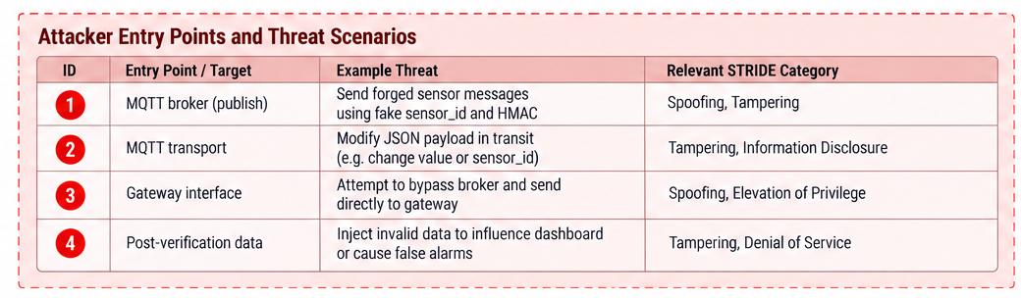
Figure 2: Authorised MQTT attack entry points and corresponding STRIDE threat categories.

4. Security Controls & Implementation

4.1 Application-layer integrity verification
Each sensor signs its message with HMAC-SHA256. The Python gateway independently calculates the expected signature and compares it with the received one. When a value changes without a valid new signature, the gateway rejects it (Krawczyk, Bellare & Canetti 1997).

4.2 Verification and acceptance workflow
The broker delivers MQTT messages but does not decide whether a measurement is trustworthy. The gateway parses the JSON structure, validates the sensor identity and required fields, compares the HMAC and checks that sequence numbers are newer than the saved accepted state. Only messages passing those conditions update trusted monitoring data; failed integrity or freshness checks result in security events. This separates MQTT transport, cryptographic verification and monitoring (OASIS 2019).
Stage | Security function | Operator-visible outcome
Sensor publication | Publish identified measurement with HMAC | Measurement available for verification
Gateway validation | Parse payload and compare HMAC | ACCEPTED or REJECTED classification
Trusted monitoring | Update state using accepted data | Latest trusted reading displayed
Invalid publication | Discard untrusted measurement | Previously accepted value retained
Missing valid data | Track age of last accepted reading | Outage alert and SAFE/HOLD indication

4.3 Availability monitoring and protective state
HMAC helps detect changed data, but it cannot keep a sensor online. We therefore also monitor when the last valid reading arrived. If readings stop, the dashboard shows an outage or SAFE/HOLD warning; it does not control physical farm equipment.

4.4 Access boundaries and security limitations
The demonstration separates legitimate publishers, the verification gateway, monitoring and an attacker using GNS3 Docker nodes and MQTT topics. These boundaries enable controlled testing but are not broker-enforced isolation or production network segmentation. HMAC does not encrypt MQTT payloads. The gateway adds replay checking, while private brokers, authenticated sessions, restrictive ACLs, TLS and individual device credentials are future operational safeguards (Eclipse Foundation n.d.; OASIS 2019).

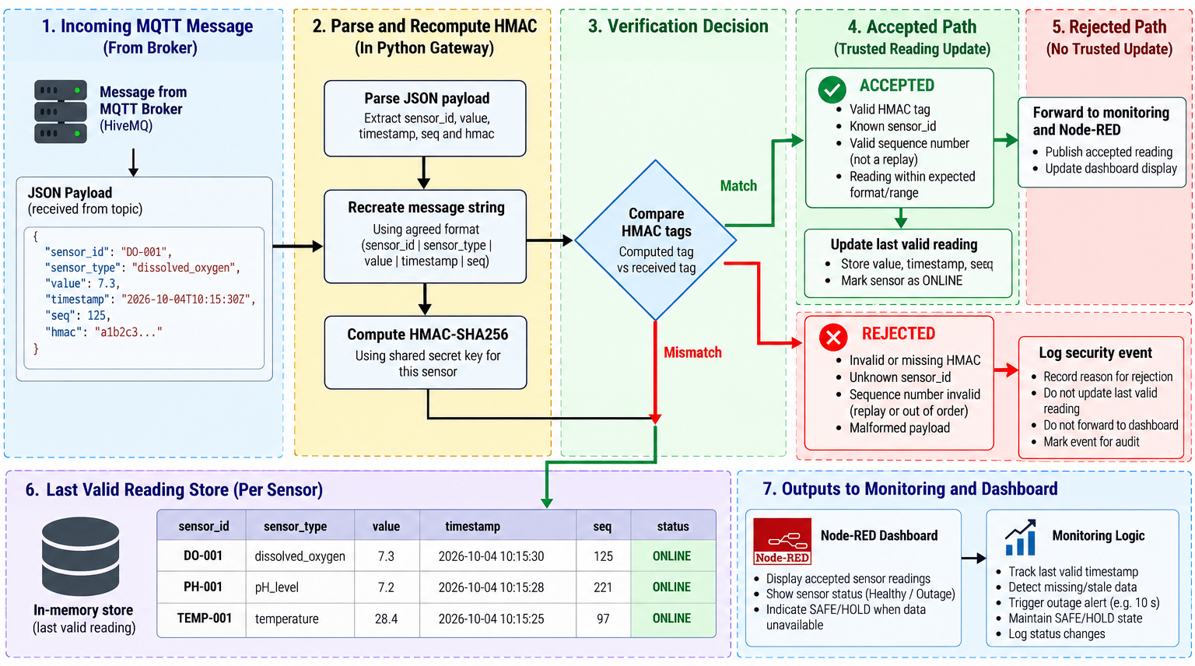
Figure 3: Gateway verification decision and accepted-versus-rejected monitoring paths.

5. Attack Scenarios & Defence Strategy

5.1 Authorised attack environment
We use the project attacker node only for our authorised lab tests. The supplied scripts let us send invalid messages or try replaying earlier packets on the simulated sensor topics. A second team computer is an optional route, but we do not claim that test was successful without recorded evidence.

5.2 Message tampering and sensor impersonation
In a message-tampering case, an adversary alters a signed measurement while retaining its original authentication tag; the gateway calculates a different HMAC and must reject it. A forged-identity case likewise cannot be trusted without the correct signing material. A captured authentic message presents a different problem: the HMAC may remain valid, so the gateway in the provided project compares its sequence with the saved last accepted sequence and rejects duplicates or older values. Shared keys still do not prove hardware-bound identity.

5.3 Loss of valid telemetry
The availability scenario interrupts legitimate sensor reporting and observes the monitoring response. Invalid attacker messages are not equivalent to valid sensor updates and therefore cannot be treated as evidence that the sensor is healthy. The dashboard presents the last accepted data and a sensor availability or SAFE/HOLD indication when trusted sensor data is absent. The control is an dashboard software demonstration rather than an automated industrial actuator command.

5.4 Threat response and residual exposure
Scenario | Demonstrated defence | Residual risk
Modified sensor value | HMAC mismatch causes rejection | A stolen shared secret could allow forged valid tags
False sensor identifier | Valid tag required for acceptance | Shared keys do not provide unique physical identity
Sensor communication outage | Availability alert and SAFE/HOLD indication | Broker-wide disruption can still prevent updates
Replay of valid signed traffic | Sequence-based rejection shown for DO-001 in supplied log | Protect replay state against loss/tampering; timestamps for ESP32 are uptime-based
MQTT traffic interception | Application integrity remains independently checked | Confidentiality requires TLS
Unauthorised broker access | Gateway rejects messages without valid tags | Broker authentication and topic ACLs remain necessary

5.5 Defence-in-depth for an operational farm
A production farm should retain the implemented integrity, sequence-checking and outage-monitoring controls as part of defence in depth. Individual device secrets and secure provisioning limit the effect of credential compromise; authenticated MQTT sessions, ACLs and TLS restrict access and protect message confidentiality. Network segmentation, protected state storage and audit/recovery procedures strengthen the system beyond this university prototype (Eclipse Foundation n.d.; Microsoft n.d.).
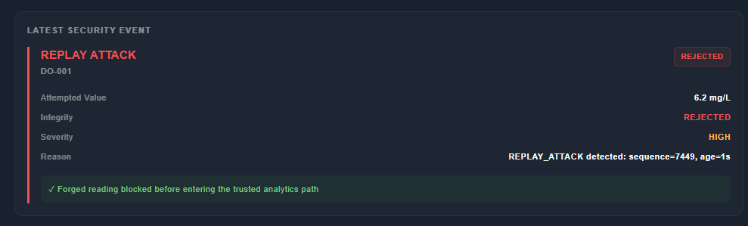Figure 4: Node-RED security event identifying an attempted replay and rejection.Authorised attacker publication, gateway rejection and trusted dashboard response.

6. Residual Risks & Security Improvements

6.1 Residual risk evaluation
The AQ-1 prototype prioritises application-level integrity checking and awareness of missing trusted telemetry. These controls reduce the risk of accepting altered sensor values but do not remove every threat to the MQTT system. The residual risks below describe the boundaries of the implemented demonstration and the additional safeguards appropriate to an real farm.
Residual risk | Why it remains | Production treatment
Replay of valid messages | An HMAC can remain valid when a previously signed payload is resent. | Gateway implements persistent sequence rejection; strengthen replay-state integrity
Shared-secret compromise | Possession of the signing key enables creation of apparently valid messages. | Use device-specific secrets, restricted storage, rotation and revocation.
MQTT interception | HMAC does not encrypt sensor values or metadata. | Use authenticated MQTT sessions and TLS on suitable links.
Broker misuse or disruption | Application verification cannot prevent all broker overload or unauthorised topic use. | Apply topic ACLs, network isolation, rate controls and service monitoring.
Sensor or host compromise | A compromised authorised endpoint may sign false measurements. | Harden endpoints, protect credentials and add plausibility and cross-sensor checks.

6.2 Prioritised security improvements
For future deployment, priorities include per-device identity and key rotation, resilient replay-state storage, MQTT authentication and topic-level authorisation. TLS protects messages in transit, while segmented networks restrict exposure of the broker and dashboard. Monitoring, protected logging and incident recovery improve the response to missing or suspicious data. These measures complement, rather than replace, the HMAC and sequence validation already present in the demonstration (Krawczyk, Bellare & Canetti 1997; Eclipse Foundation n.d.).

6.3 Safety and operational implications
A valid cryptographic tag confirms knowledge of a secret, not the physical correctness of a measurement. The operational design therefore treats implausible readings, communication loss and stale data as separate safety concerns. SAFE/HOLD represents a conservative monitoring state when reliable information is unavailable; the university demonstration does not actuate aerators, pumps or feeders. Any real control integration would require equipment-specific safety interlocks, manual override and commissioning.
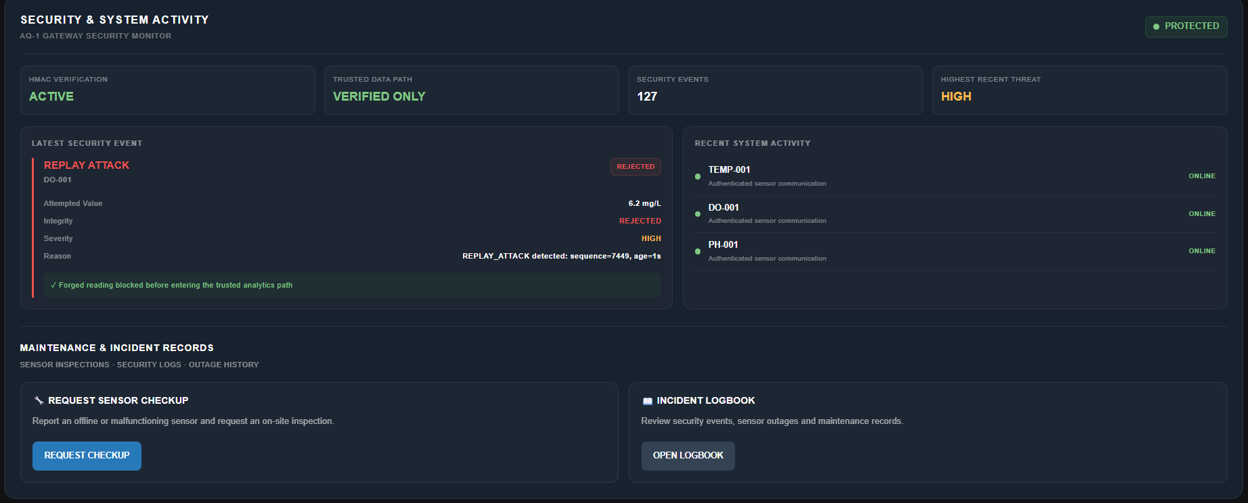Figure 5: Node-RED security activity screen showing monitoring and incident records.

7. Security Assessment Summary

7.1 Threat-to-control assessment
The assessment links each significant threat to a defined trust boundary and a practical control. The table distinguishes demonstrated cryptographic behaviour from controls identified for production deployment. Risk ratings are qualitative engineering judgements for the AQ-1 scenario, not measured probabilities.
Threat | Prototype treatment | Residual exposure
Tampered measurement | HMAC-SHA256 comparison rejects a changed value carrying an invalid tag. | Key theft or compromise of an authorised signer.
Sensor impersonation | Unsigned or incorrectly signed traffic is not accepted as trusted. | A shared key does not prove unique physical-device identity.
Loss of sensor reporting | Last-valid-reading monitoring and SAFE/HOLD indication represent the loss of dependable telemetry. | Broker-wide outages and real actuator safety are outside prototype scope.
Replay of signed reading | Gateway rejects duplicate/older authenticated sequence numbers in supplied test | Replay-state robustness and time freshness remain limited
Traffic disclosure and broker access | Logical verification boundaries; HMAC authenticates messages | TLS, ACLs and stronger broker authentication are production enhancements.

7.2 Security architecture outcome
The key security decision happens at the gateway. MQTT can deliver a message, but only a message that passes the gateway checks becomes trusted data. This approach helps us distinguish valid sensor readings from tampered or missing information.

7.3 Assessment boundaries
The threat assessment covers a university prototype with physical temperature, simulated DO/pH sources, public HiveMQ transport, Python verification, Node-RED monitoring and an authorised attacker in GNS3. It does not claim industrial sensor certification, hardware-protected cryptographic keys, MQTT TLS, broker-enforced ACLs or physical equipment actuation. Sequence-based replay rejection is implemented in the transferred gateway, but large-scale deployment, long-term recovery and adversarial key compromise were not validated.

7.4 Artefact traceability and conclusion
Technical Artefact 1 documents the reference system design; Artefact 2 records the prototype deployment; this artefact explains its security boundaries and threat treatment. Artefact 4 contains attack demonstrations, Artefact 5 addresses validation, Artefact 6 provides source and configuration material, and Artefact 7 describes reproduction. Together they establish a traceable distinction between architectural intent, prototype implementation and observed results.
The central finding is that broker delivery alone cannot make telemetry trustworthy. Gateway-based HMAC verification provides an integrity barrier, sequence checking reduces replay risk and independent availability monitoring identifies the absence of accepted data. A real farm deployment would combine these protections with authenticated endpoints, encrypted MQTT transport, operational segmentation, protected keys and commissioned safety controls. The university implementation demonstrates the principle and its limits rather than a completed industrial deployment.

References
AQ-1 project team 2026, AQ-1 secure aquaculture IoT, GitHub repository, <https://github.com/nininehaa/aq1-secure-aquaculture-iot>.
Eclipse Foundation n.d., Eclipse Mosquitto documentation, Eclipse Foundation, <https://mosquitto.org/documentation/>.
Krawczyk, H, Bellare, M & Canetti, R 1997, HMAC: Keyed-Hashing for Message Authentication, RFC 2104, Internet Engineering Task Force, <https://www.rfc-editor.org/rfc/rfc2104>.
Microsoft n.d., Threat modeling tool threats, Microsoft Learn, <https://learn.microsoft.com/en-us/azure/security/develop/threat-modeling-tool-threats>.
OASIS 2019, MQTT version 5.0, OASIS Standard, <https://docs.oasis-open.org/mqtt/mqtt/v5.0/mqtt-v5.0.html>.

